**Test Plan: Operations in Ashumet Pond and the Charles River with JetYaks and SandSharks, September 2019**

***Objectives:*** Collect data in Ashumet Pond for determining a speed vs propeller turns table for the current SandShark configuration. Collect current data in the Charles River to assist in the evolution of a new Extended Kalman Filter.

***Dates: TBD***

***Travel:***

Day 1- WHOI team to drive to Ashumet Pond to conduct shakedown. If successful, conduct Doppler and speed vs propeller turns testing.

Day 2- WHOI team drive to MIT Sailing Pavilion to conduct Doppler and current testing

30 minute drive to Ashumet Pond.

Approximately 2 hour drive to MIT Sailing Pavilion

*Boat ramp: Ashumet Pond - ample parking.*

*Parking at Sailing Pavilion?*

***WHOI Personnel attending?:***

Chris Dolan

Caileigh Fitzgerald

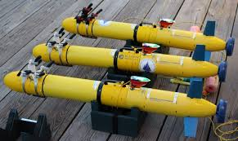

***Equipment:***

SandShark AUV(x2) with piUSBL

* Length: ~6’
* Weight: ~200lbs

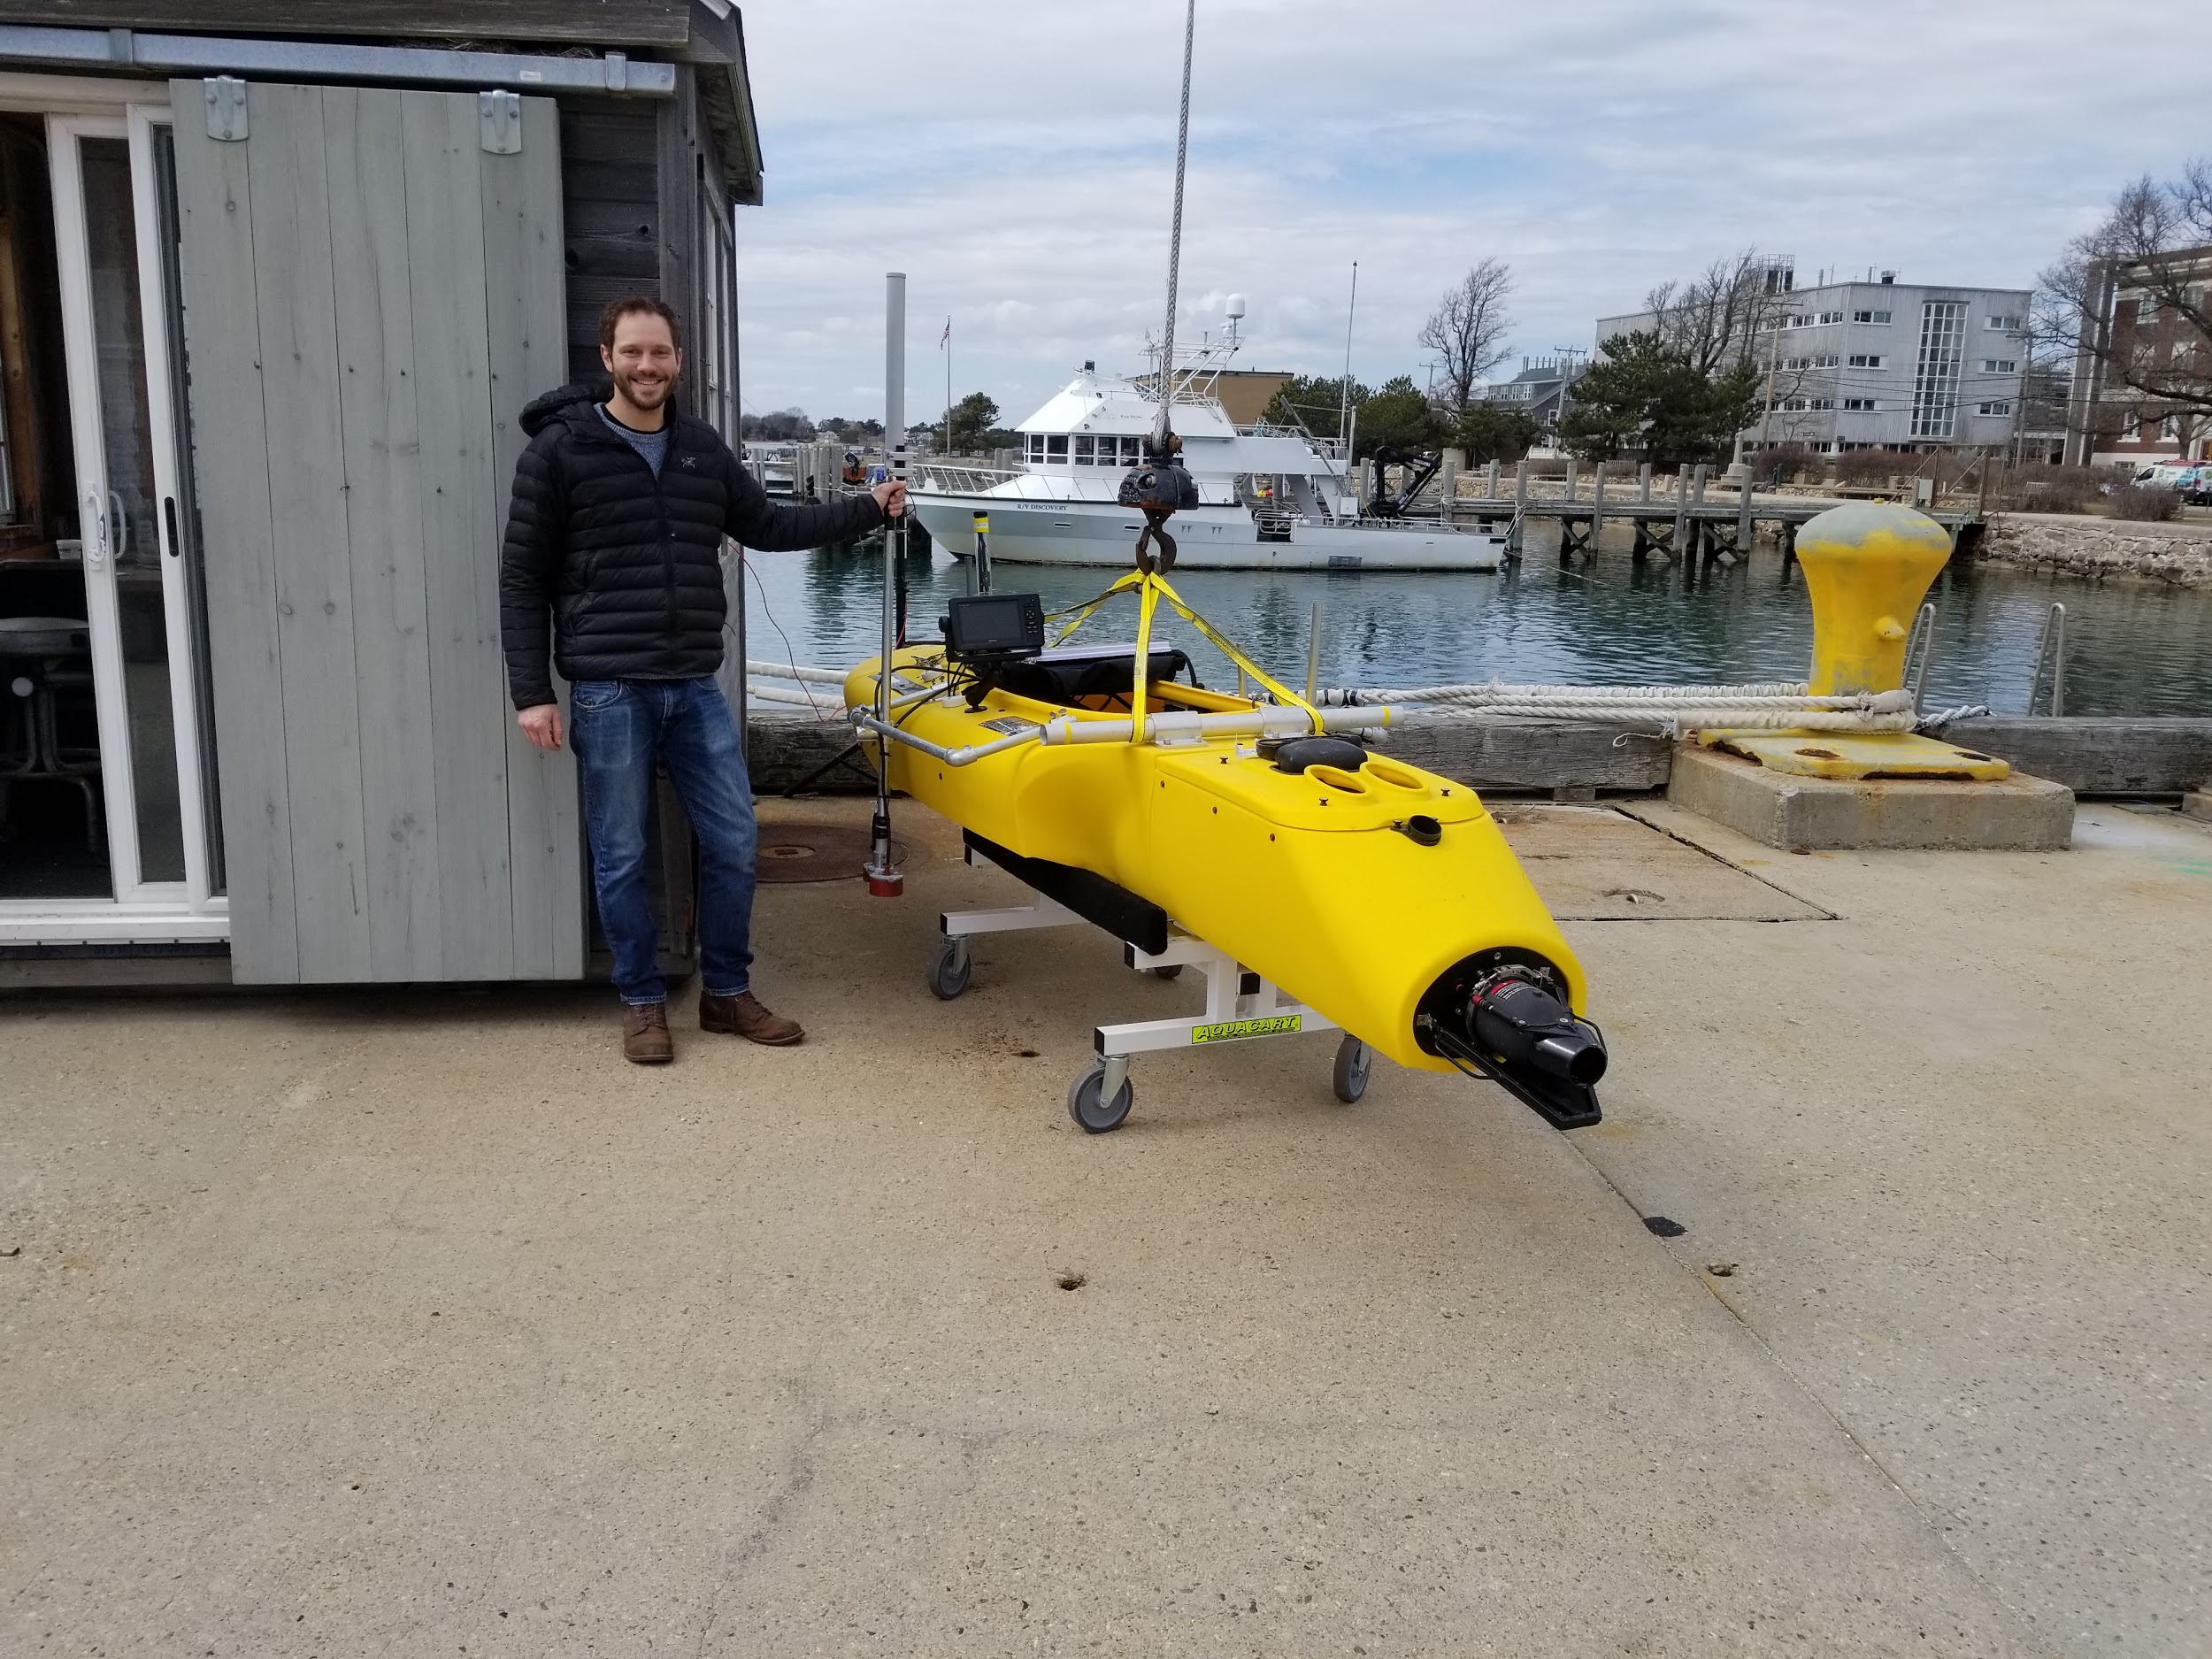

JetYak ASV with Signature 1000 ADCP and iUSBL

* Length: ~11’
* Width:~3’
* Weight:~200lbs

iUSBL/LBL Transducers

***General Operation Plan***

***Day 1:***

Transport the JetYak and SandSharks to Ashumet Pond. Conduct shakedown testing to determine if all systems are functioning properly. If shakedown successful, continue on to acoustic Doppler and speed vs propeller turn testing

***Day 2:***

Transport the JetYak and SandSharks to the MIT Sailing Pavilion. Collect current data with the JetYak with the SandSharks following recording iUSBL positions and acoustic Doppler shift data.

***Site Information:***

**Site 1: Ashumet Pond**

*Information: Public boat launch*

*Water Depth:* 5-65ft.

*Current and Tides:*

*Desired Surveys: Shakedown and equipment tests for both SandSharks and JetYak to veify functionality and ability to record desired data. Lawnmower surveys for speed vs propeller RPM(SandSharks) and Doppler data(all).*

**Site 2: Charles River/MIT Sailing Pavilion**

*Information: Time on the water limited by crew shells in the early morning and sailing classes after lunch*

*Water depth:* 9-18ft

*Current and tides:*

*Desired Surveys: Lawnmower patterns led by the JetYak with the SandSharks following to record current and Doppler data.*

***Science objectives:***

Acoustics:

* Assess the viability of using Doppler shift to measure relative water referenced speed between a source and receiver.

Hydrodynamics:

* Determine a speed vs propeller RPM table for each SandShark in its current configuration.

Environmental data:

* Measure current in the Charles River to validate output of Extended Kalman Filter.

Data we will collect:

* Sandsharks:
  + position(piUSBL), course over ground(piUSBL), speed over ground(piUSBL), heading(AHRS), propeller RPM(front seat?), iUSBL Doppler(new system?)
* JetYak:
  + Position(GPS), course over ground(GPS), speed over ground(GPS), current(DVL), iUSBL Doppler(new system?), heading(AHRS?)